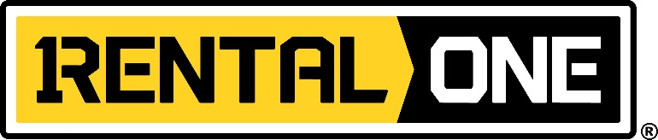

**Press Contact:** Doug Miller

Head of Media Relations

[Doug.Miller@R1Equip.com](mailto:Doug.Miller@R1Equip.com)

817.684.5829

**4101 Gateway Drive Colleyville, TX 76034** [***R1Equip.com***](http://r1equip.com/)[](https://www.linkedin.com/company/rental-one/)[](https://twitter.com/r1equip) 

FOR IMMEDIATE RELEASE

**EQUIPMENT RENTAL LEADER ANNOUNCES PARTNERSHIP TO HELP PROVIDE CLEAN DRINKING WATER**

***Equipment rental leader, Rental One, will donate a portion of bottled water proceeds to Living Water International this summer.***

**COLLEYVILLE, Texas, July 24, 2019** – [Rental One](https://r1equip.com/) announced that this summer they will donate a portion of bottled water proceeds to Living Water International. This partnership coincides with Rental One’s mission to Serve Others with Excellence and their desire to make an impact not only within their community but also abroad.

“We are excited to partner with and give to such an impactful organization this summer. Our goal is to always Serve Others with Excellence and Living Water International’s mission is one that resonates with all of us at Rental One,” said [Mike O’Neal](https://r1equip.com/company/), Rental One’s President.

[Living Water International](https://water.cc/) exists to demonstrate the love of God by helping communities acquire desperately needed clean water, and to experience “living water” –the gospel of Jesus Christ- which alone satisfies the deepest thirsts. Living Water has completed over 20,000 water projects serving roughly 5 million people in their 25 years.

Visit your local Rental One [location](https://r1equip.com/locations/) to learn more and support Rental One and Living Water International’s effort to provide safe water across the globe.

**About Rental One:**

[Rental One’s](http://r1equip.com/company/company-overview/) deep Texas roots go back **three generations.** The family’s genuine commitment to serving the rental equipment community with excellence has established an unparalleled industry reputation of reliability and integrity. This commitment is what propels [Rental One](http://r1equip.com/) as we continue to grow.

[Rental One](http://r1equip.com/) rents only top, brand name [construction equipment](http://r1equip.com/equipment/) and makes available job-site [storage containers and mobile offices](http://r1equip.com/equipment/containers-mobile-offices/) to the construction community. Through [R1 Supply](http://r1supply.com/), they offer professional assistance and construction supplies to contractors and do-it-yourself homeowners alike.

If you would like more information about this topic, please call Doug Miller at 817.684.5829, or email [Doug.Miller@R1equip.com](mailto:Doug.Miller@R1equip.com).